# The Animal Tracker Database (CS-340: Project 2)

## About the Project

*The Animal Tracker Database is both a web application and custom Python MongoDB module for CRUD database transactions with the non-relational MongoDB.*

## Motivation

*The (not-so-original) invention of a set of tools for CRUD operations on a MongoDB server, and the visualisation of data from its returned documents, was motivated by the problem of identifying the optimal animal candidates for rescue missions stored in a non-relational manner.*

## Getting Started

*The needed apparatus is a MongoDB database on some server, the Python programming language, and various third-party Python libraries for the CRUD module. Installation of this application involves downloading the programme files into an arbitrary folder, and optionally setting up a Python virtual environment for the third-party libraries.*

## Usage

*After running the application, the end user should navigate to the instance of The Animal Tracker web application on their browser. The application will show something like this:*

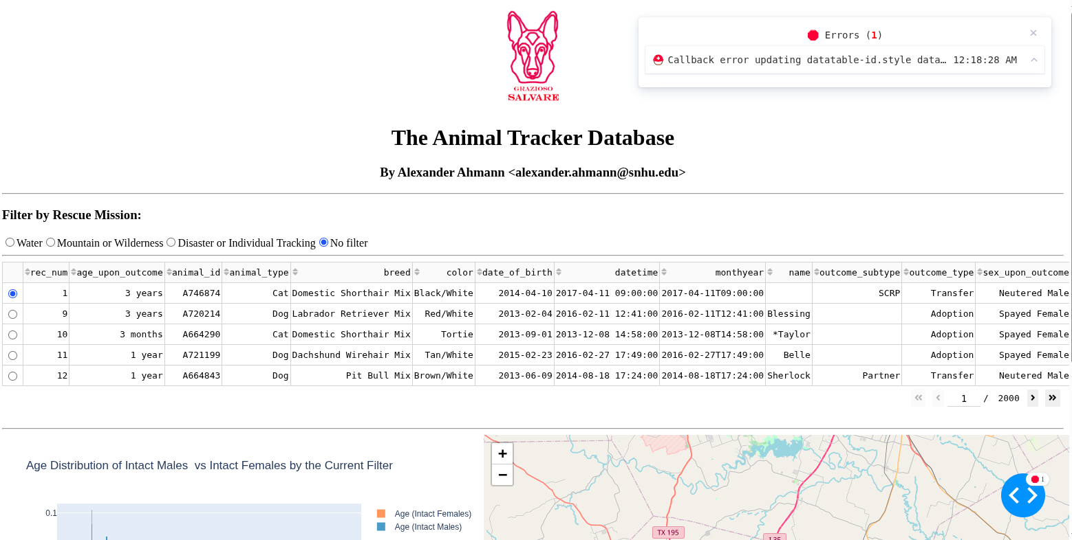

*There is a table on the top half of the dashboard, and frequency KDE plot and geolocation chart on the bottom half. There are radio buttons above the table, which will instruct the web application to return only the optimal animals for a rescue mission, as defined in a specifications document.*

*The following is an example of the dashboard selecting for animals that are the optimal candidates for “disaster and individual tracking”-type rescue missions:*

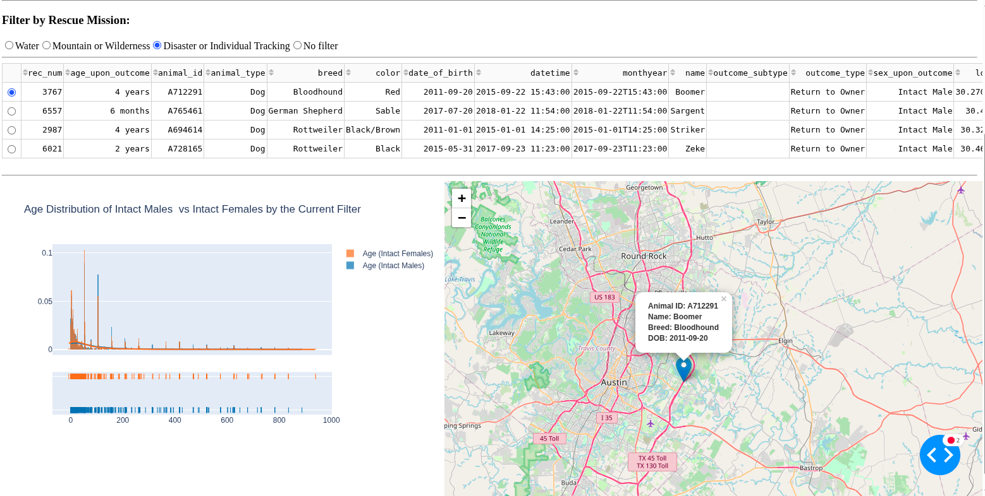

## Further Work

*More progress is needed to make the web application ready for production: further stress testing is needed, as well as refinements of the codebase. In particular, I have identified at least two (2) runtime error message as the web application is executing.*

## Contact

I am Alexander Ahmann. Interested end-users may out to me by the following means:

* Email: [alexander.ahmann@snhu.edu](mailto:alexander.ahmann@snhu.edu)
* GitHub: <https://github.com/Alekseyyy>